Bungalow Near Nagpur.

1. Project Information
- Project Name: Dwarkamai
- Location: __________________
- Plot Area: __________________
- Built-up Area: __________________
- Project Type: Luxury row-house / bungalow development
- Status: __________________
- Completion Year: __________________

2. Project Overview
Dwarkamai is a contemporary low-rise residential development comprising a series of luxury bungalows with a unified architectural identity. The design combines spacious balconies, private entrances and landscaped surroundings with modern materials and warm lighting. Repeated façade elements create continuity while maintaining individuality for each residence.

3. Building Features
- Multiple interconnected luxury bungalows
- Private entrances and covered parking
- Large balconies with glass railings
- Natural stone and wood-finish façade cladding
- Pergola-style terrace roofs
- Decorative screens and vertical fins
- Large windows for natural light and ventilation
- Landscaped balconies and boundary edges
- Integrated façade and pathway lighting
- Secure common entrance driveway
- Contemporary compound-wall design
- Semi-covered internal vehicular circulation

4. Overall Design Concept
The design combines strong geometric frames with natural stone, timber finishes and lightweight pergolas. Repeated vertical elements create rhythm across the development, while balconies, greenery and warm lighting soften the overall mass. The concept delivers a modern, cohesive and premium residential environment.

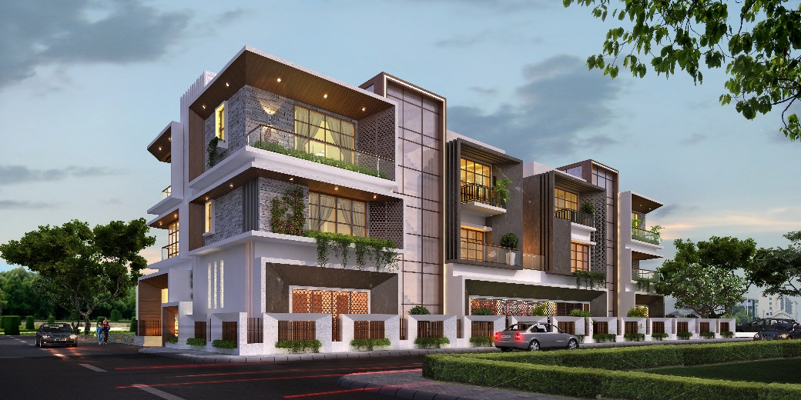
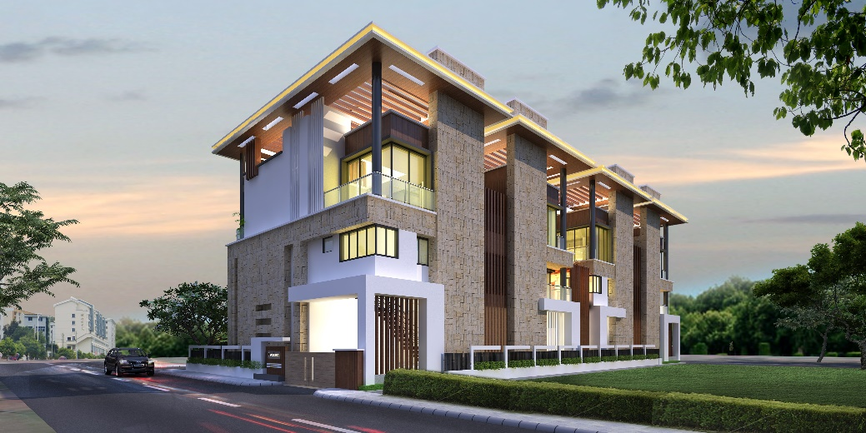
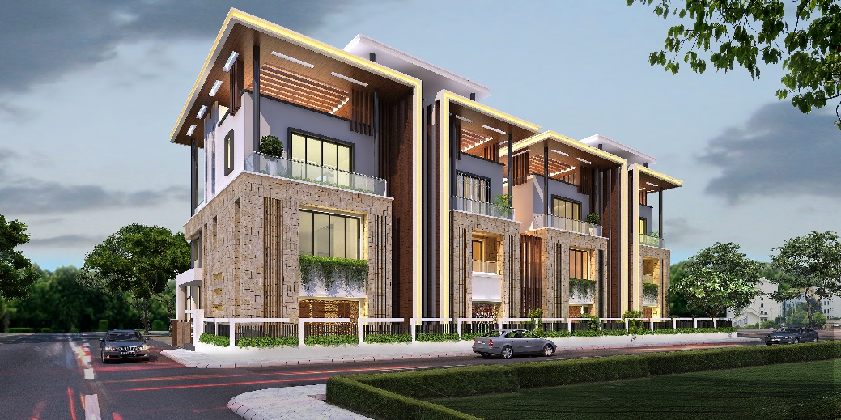
Image 1
Image 2
Image 3

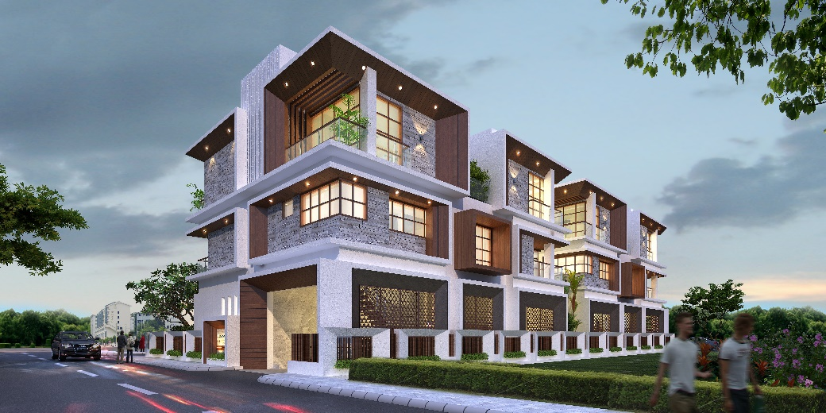
Image 4

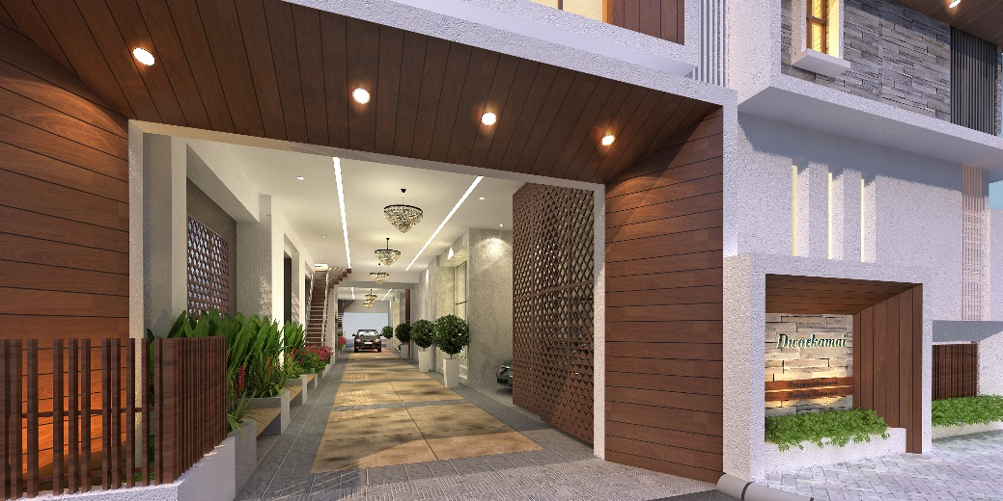
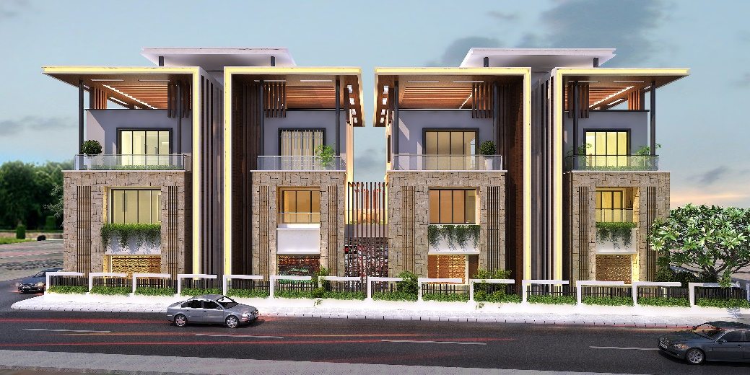
Image 5
Image 6

